Critical Analysis of GeM Tractors (V3) Interface
Website: Government e-Marketplace (GeM) – Tractors (V3)
Objective: Analyze the interface based on HCI principles and Shneiderman’s Golden Rules.

Introduction
The GeM Tractors (V3) page allows government buyers to browse tractor listings. While the website is trustworthy and information-rich, several interface design issues reduce ease of use, especially for first-time users.

Figure 1
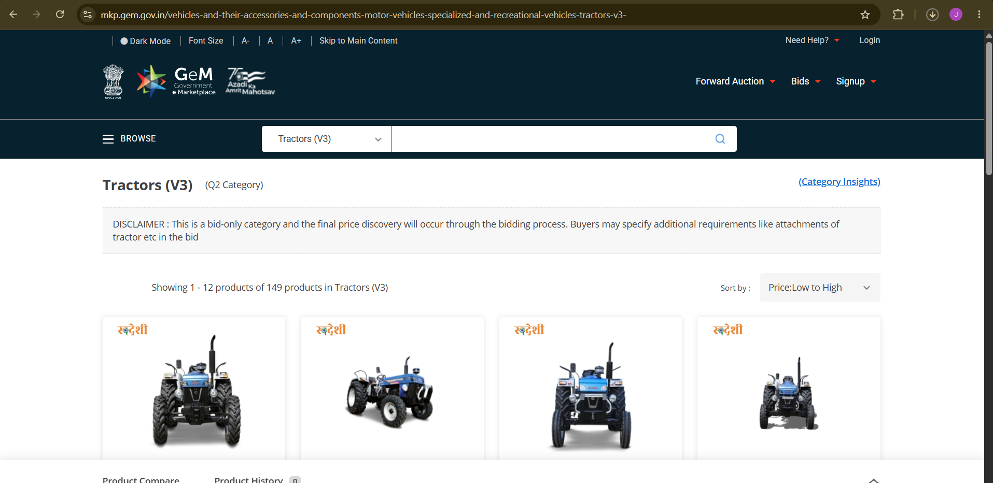
Screenshot 1: Product listing interface of GeM Tractors (V3).

Figure 2
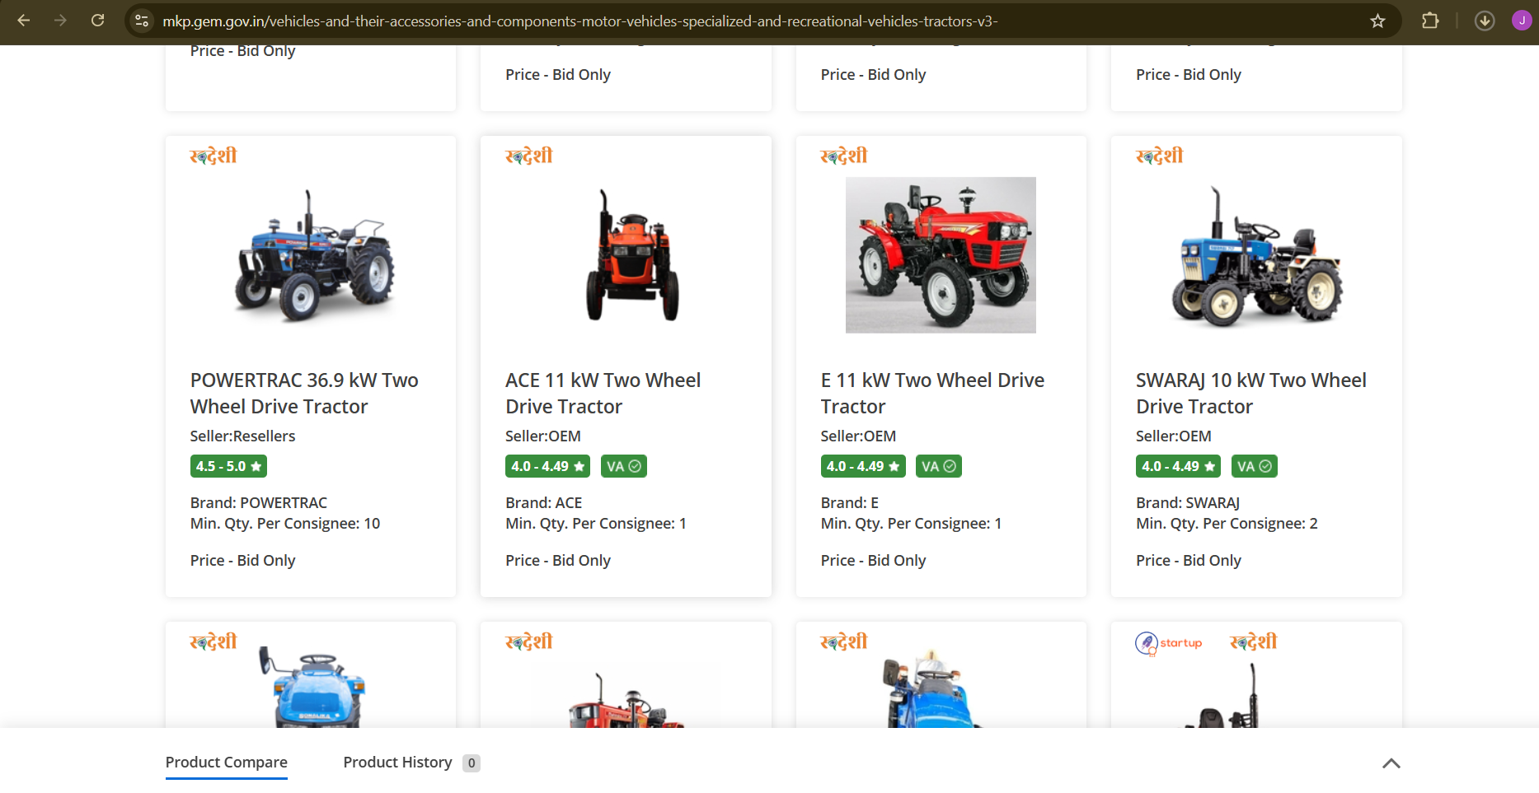
Screenshot 2: Product listing interface of GeM Tractors (V3).

Figure 3
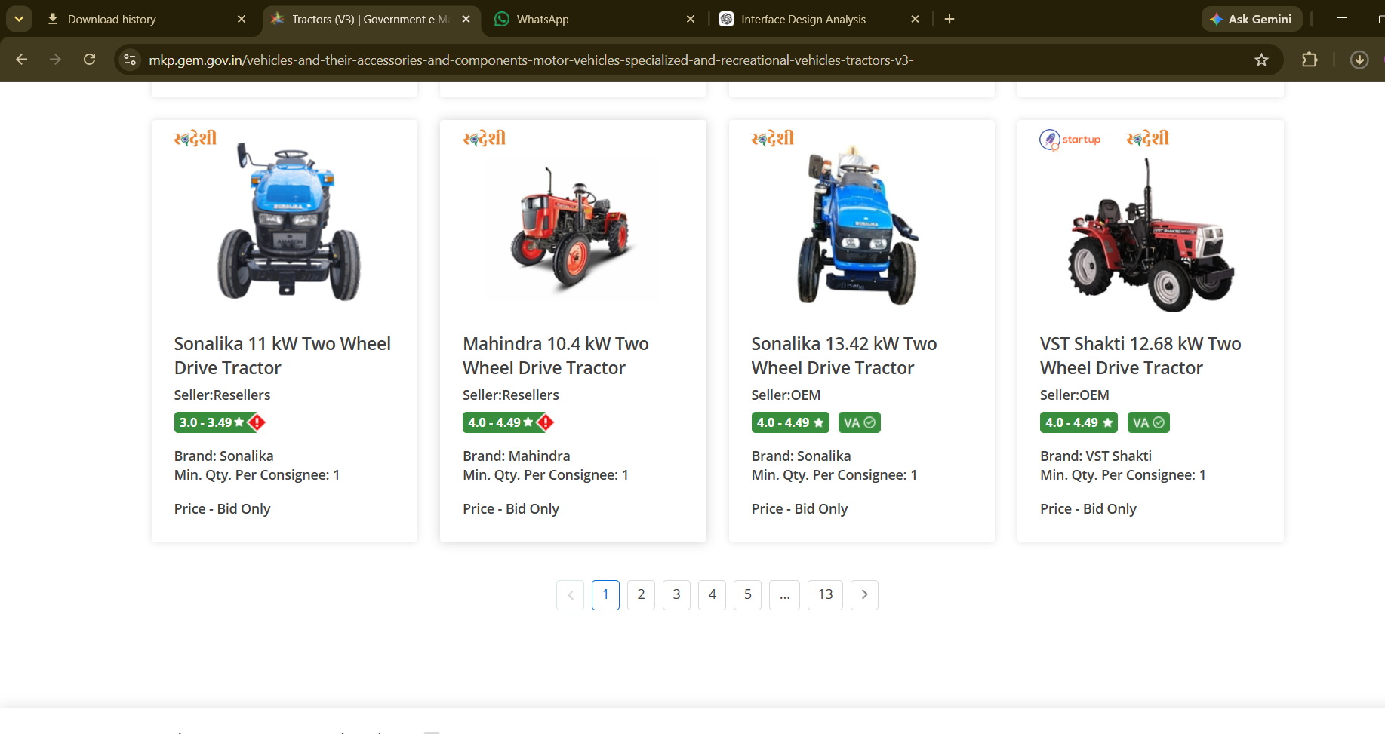
Screenshot 3: Product listing interface of GeM Tractors (V3).

Interface Evaluation
Parameter | Observation | Rating
Learnability | Search bar is visible but first-time users may struggle to understand bid-only workflow. | 3.5/5
Usability | Filtering is limited and important actions require scrolling. | 3.5/5
Consistency | Cards, fonts and colors remain consistent. | 4.5/5
Use of Metaphors | Uses search icon, menu icon and rating badges effectively. | 4/5
Navigation Structure | Simple but lacks breadcrumbs and richer filtering. | 3.5/5
Visual Hierarchy | Product cards dominate while actions are less prominent. | 4/5
Accessibility | Font size option exists but contrast and keyboard cues can improve. | 3.5/5
Responsiveness | Desktop layout is good; dense layout may affect mobile. | 4/5
Efficiency | Finding products requires significant scrolling. | 3/5
Feedback | Limited loading/progress feedback. | 3/5
Error Prevention | Search/filter validation can improve. | 3.5/5
Minimalist Design | Generally clean but repetitive cards create clutter. | 4/5
Content Readability | Readable fonts and spacing. | 4/5
Search & Discoverability | Search present but advanced filters are limited. | 3.5/5
Performance Perception | Fast page with minimal transitions. | 4/5
Trust & Credibility | Government branding increases trust. | 5/5
Personalization | No personalized recommendations. | 2/5
User Satisfaction | Functional but not highly engaging. | 3.5/5

Shneiderman's Eight Golden Rules
- Strive for consistency: Mostly followed through uniform cards and colors.
- Seek universal usability: Partially followed; more accessibility support needed.
- Offer informative feedback: Needs better loading and confirmation messages.
- Design dialogs to yield closure: Bid flow could communicate completion more clearly.
- Prevent errors: More validation and guidance should be added.
- Permit easy reversal of actions: Limited undo/cancel visibility.
- Keep users in control: Navigation is straightforward but filters are basic.
- Reduce short-term memory load: Persistent search helps, but comparison features can improve.

Strengths
- Professional government branding.
- Consistent layout.
- Good readability.
- Clear product cards.
- Visible search bar.

Weaknesses
- Limited filters.
- Too much scrolling.
- Weak visual emphasis on primary actions.
- Limited feedback.
- No personalization.

Recommendations
- Add advanced filters and sticky filter panel.
- Improve accessibility and keyboard navigation.
- Provide better loading indicators.
- Highlight bid actions with stronger visual hierarchy.
- Offer personalized recent/history recommendations.

Conclusion
The GeM Tractors (V3) interface is reliable and consistent but can be improved in learnability, discoverability, accessibility and interaction efficiency. Implementing standard HCI principles and Shneiderman's Golden Rules would significantly improve the user experience.

